EXPERIMENT NO. 2
SIGNAL OPERATIONS AND TRANSFORMATIONS

OBJECTIVE:
(i) To perform amplitude scaling and time scaling of continuous-time and discrete-time signals and analyze their effects on signal characteristics.
(ii) To perform addition and multiplication of two discrete-time sequences and analyze the resulting signal characteristics.

MATLAB CODING:
% Experiment 2(i): Amplitude and Time Scaling
clc; clear; close all;
t = -1:0.001:1;
x = sin(2*pi*5*t);
yA = 2*x;
yC = sin(2*pi*5*(2*t));
yE = sin(2*pi*5*(t/2));
figure;
subplot(2,2,1); plot(t,x); grid on;
title('Original x(t)'); xlabel('Time (s)'); ylabel('Amplitude');
subplot(2,2,2); plot(t,yA); grid on;
title('Amplitude Scaling: 2x(t)'); xlabel('Time (s)'); ylabel('Amplitude');
subplot(2,2,3); plot(t,yC); grid on;
title('Time Compression: x(2t)'); xlabel('Time (s)'); ylabel('Amplitude');
subplot(2,2,4); plot(t,yE); grid on;
title('Time Expansion: x(t/2)'); xlabel('Time (s)'); ylabel('Amplitude');

MATLAB CODING:
% Experiment 2(iii): Addition and Multiplication of Two Sequencesclc; clear; close all;
n = 0:2;
x = [1 2 1];
y = [1 1 2];
zSum = x + y;
zProd = x .* y;
figure;
subplot(2,2,1); stem(n,x,'filled'); grid on;
title('x[n]'); xlabel('n'); ylabel('Amplitude');
subplot(2,2,2); stem(n,y,'filled'); grid on;
title('y[n]'); xlabel('n'); ylabel('Amplitude');
subplot(2,2,3); stem(n,zSum,'filled'); grid on;
title('Addition x[n]+y[n]'); xlabel('n'); ylabel('Amplitude');
subplot(2,2,4); stem(n,zProd,'filled'); grid on;
title('Multiplication x[n]y[n]'); xlabel('n'); ylabel('Amplitude');

OUTPUT :
To perform amplitude scaling and time scaling of continuous-time and discrete-time signals and analyze their effects on signal characteristics.
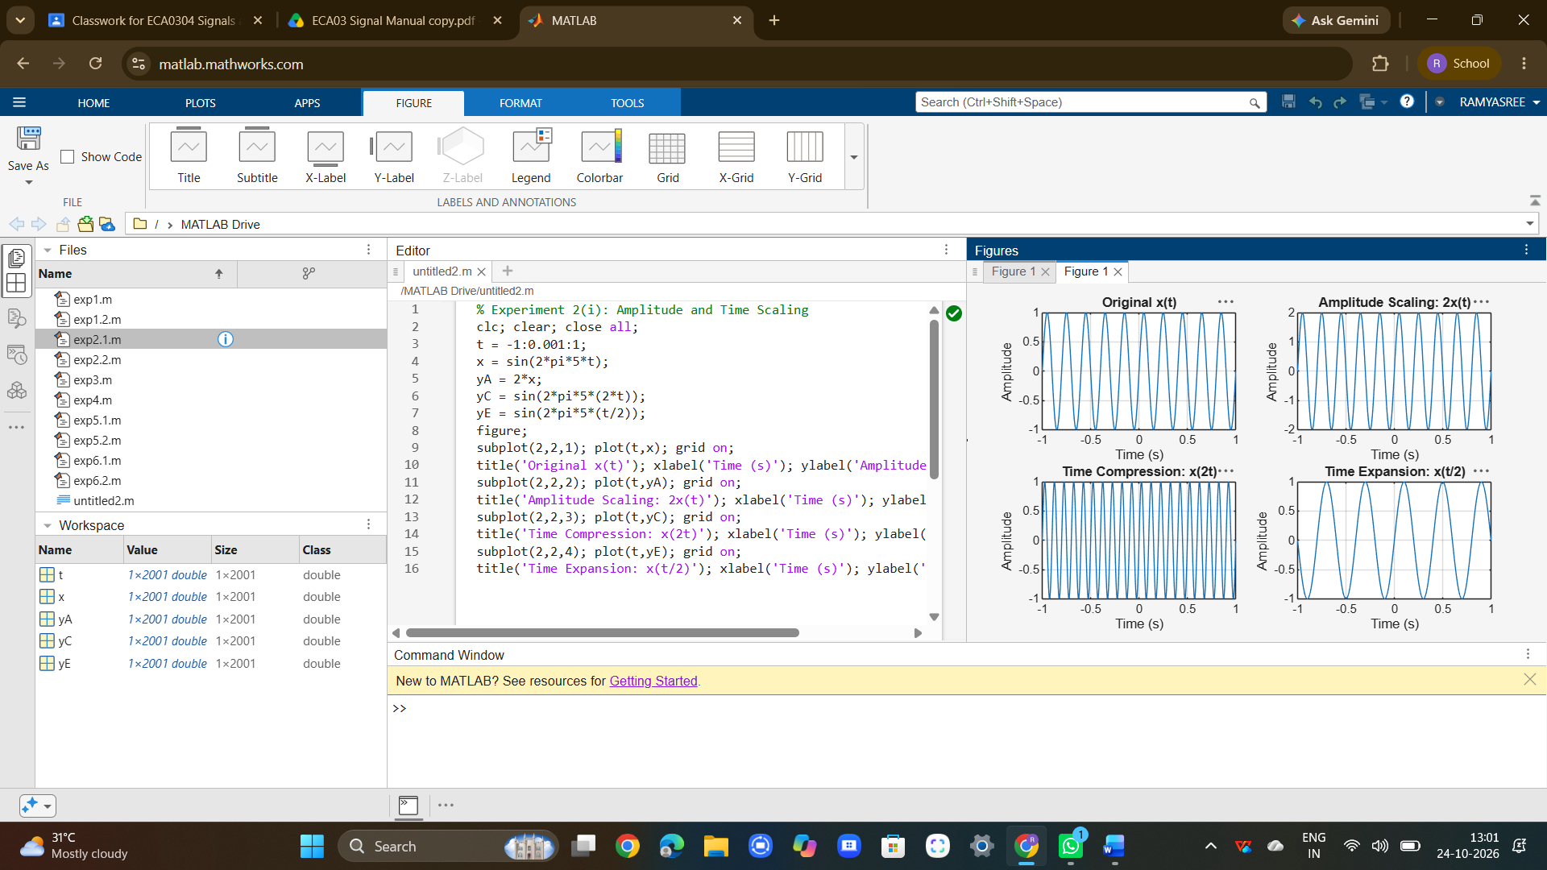
To perform addition and multiplication of two discrete-time sequences and analyze the resulting signal characteristics.
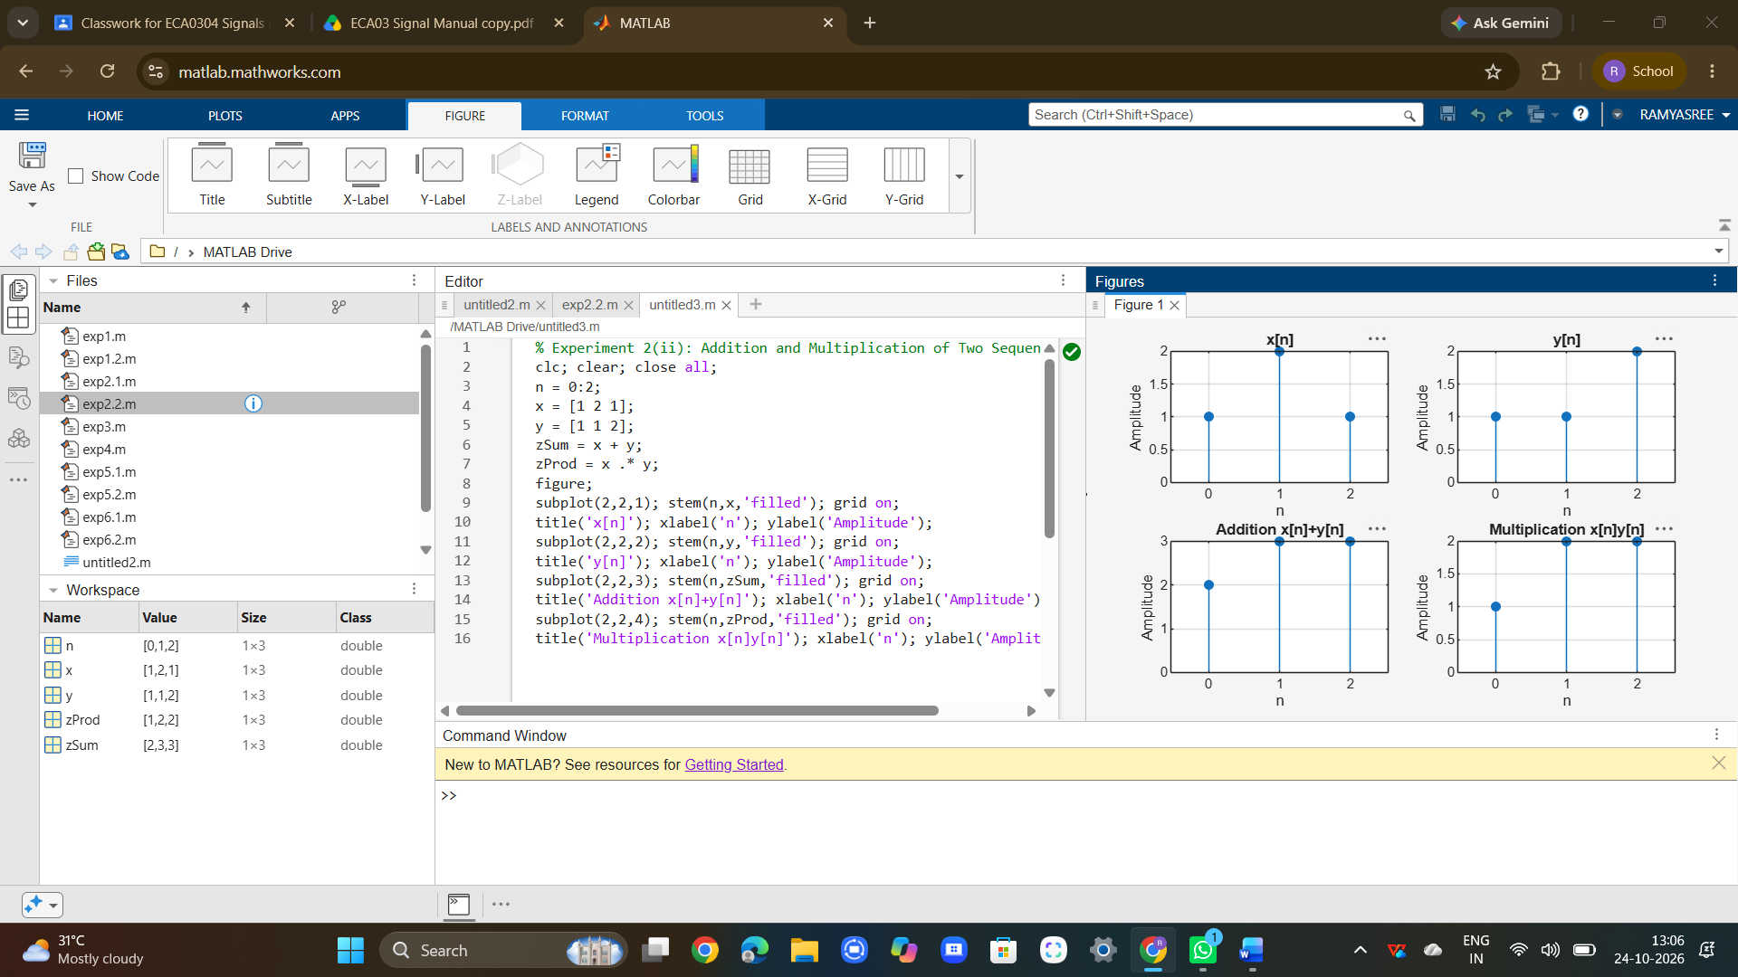

RESULT :
Amplitude and time scaling, time shifting, time reversal, sequence addition and sequence multiplication were successfully implemented. The original and transformed signals were compared, and the observed waveform changes agreed with the corresponding theoretical signal-operation relationships.

